GRETA SKYA

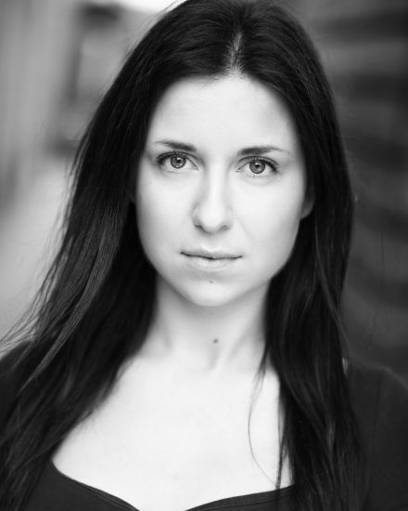

**Playing age: 20-29**

**Height: 5”4**

**Weight: 47kg**

**Build: Petite/Slim**

**Hair: Dark brown**

**Eye colour: Green**

**Contact details:**

**Mobile: 07446065951**

**Agent: I AM EPIC**

**Equity: 00437192**

**Spotlight: 1892-4530-6054**

**Email: gretaskya@mail.com**

|  |  |  |  |  |  |  |  |  |  |  |  |  |  |  |  |  |  |  |  |  |  |  |  |  |  |  |  |  |  |  |  |  |  |  |  |  |  |  |  |  |  |  |  |  |  |  |  |  |  |  |  |  |  |  |  |  |  |  |  |  |  |  |  |  |  |  |  |  |  |  |  |  |  |  |  |  |  |  |  |  |  |  |  |  |  |  |  |  |  |  |  |  |  |  |  |  |  |  |  |  |  |  |  |  |  |  |  |  |  |  |  |  |  |  |  |  |  |  |  |  |
| --- | --- | --- | --- | --- | --- | --- | --- | --- | --- | --- | --- | --- | --- | --- | --- | --- | --- | --- | --- | --- | --- | --- | --- | --- | --- | --- | --- | --- | --- | --- | --- | --- | --- | --- | --- | --- | --- | --- | --- | --- | --- | --- | --- | --- | --- | --- | --- | --- | --- | --- | --- | --- | --- | --- | --- | --- | --- | --- | --- | --- | --- | --- | --- | --- | --- | --- | --- | --- | --- | --- | --- | --- | --- | --- | --- | --- | --- | --- | --- | --- | --- | --- | --- | --- | --- | --- | --- | --- | --- | --- | --- | --- | --- | --- | --- | --- | --- | --- | --- | --- | --- | --- | --- | --- | --- | --- | --- | --- | --- | --- | --- | --- | --- | --- | --- | --- | --- | --- | --- | --- |
| |  |  | | --- | --- | | **SKILLS:** |  | | **Accents:** | Eastern European, Russian, Standard American, English RP | | **Singing:** | Intermediate, Belt, Mezzo-Soprano | | **Dancing:** | Advanced Salsa, Bachata, Cha Cha, Tango | | **Other:** | Stage combat, Mask work, Swimming, Volleyball, Painting/Drawing |  |  |  |  |  | | --- | --- | --- | --- | | **SCREEN:** |  |  |  | | **Production** | **Role** | **Production Type** | **Company/Director** | | Rocket Man | Girl in the queue | Feature Film | Dexter Fletcher | | H Samuel TVC | Emoji girlfriend | Commercial | H Samuel | | Waitrose Christmas advert | Countdown person | Commercial | Waitrose | | The Guernsey Literary and Potato Peel Pie Society | Ballroom dancer | Feature Film | Mike Newer | | | BLU-E Cigarette | Volunteer | Commercial | BLU-E | | | Murder Recon | Victim | Documentary | POPKORN TV | | | South Eastern Railway Advert | Girlfriend | Commercial | South Eastern Trains | |   **TRAINING:**  BA Hons Degree Acting for Stage and Media, Kingston College (UWL/London College of Film)  Screen Acting Masterclass, Actors Studio (Tim Kent)  Drama diploma, Lithuanian Academy of Music and Theatre   |  |  |  |  | | --- | --- | --- | --- | | **THEATRE:** |  |  |  | | **Production** | **Role** | **Director** | **Venue/Theatre** | | The Power of Darkness | Anisya | Laura McCormack | The Arthur Cotterell Theatre | | It felt empty | Dijana | Laura McCormack | Tristan Bates Theatre | | AXE | Raskolnikov | Mayara Sartori | The Arthur Cotterell Theatre | | Private Lives | Amanda | Laura McCormack | The Arthur Cotterell Theatre | | Provoked Wife | Lady Brute | Laura McCormack | The Arthur Cotterell Theatre | | Marcuse’s Augury | Irina | Emmett Tams | The London Theare | | Twelfth Night | Olivia | Laura McCormack | The Arthur Cotterell Theatre | | The Winter’s Tale | Hermione | Laura McCormack | The Arthur Cotterell Theatre | | In The Heights | Carla | Paul Morrison | The Arthur Cotterell Theatre | | Machinal | Young Woman | Laura McCormack | The Arthur Cotterell Theatre | | Taste of Honey | Jo | Gill Amos | The Arthur Cotterell Theatre | | Thea Seagull | Arkadina | Laura McCormack | The Arthur Cotterell Theatre | | Midsummer Night’s Dream | Helena | Carlos Santos | The Arthur Cotterell Theatre | | Waiting For Godot | Estragon | Carlos Santos | The Arthur Cotterell Theatre | | | The Little Match Girl | Angel | Silvija Krivickiene | LMTA | | |